Laptop Request Catalog Item

Team Id:NM2025TMID14148

Team Members:

Gomathi.P Nivetha.v

Ashika shawfan.A Shaina banu .A

Problem Statement:

Employees in the organization need a quick and efficient way to request laptops for work. The current process is manual and prone to delays, with no dynamic form behavior to guide users or ensure accurate data collection. To address this, a Service Catalog item needs to be created, allowing users to easily request a laptop, with dynamic fields, clear instructions, and additional functionality like resetting the form if needed. The solution should also ensure all changes are tracked for governance and deployment.

Objective: To enhance company-wide productivity and security, we are procuring a

standardized,

high-performance laptop model. This critical investment provides the modern relatable

hardware necessary to support our hybrid workforce from any location.

Standardization

will streamline IT support, minimize downtime, and prepare our organization for future

growth..

Skills:

ServiceNow (Users, Roles, Incidents, Flow Designer)

Spring Framework (Backend API integration) TensorFlow (Machine Learning classification model)

TASK INITIATION

Milestone 1 : Update set

Activity 1: Create Local Update set

1. Open service now.
2. Click on All >> search for update sets
3. Select local update sets under system update sets
4. Click on new
5. Fill the following details to create a update set as: “Laptop Request”
6. Click on submit and make current
7. By clicking on the button it activates the update set .

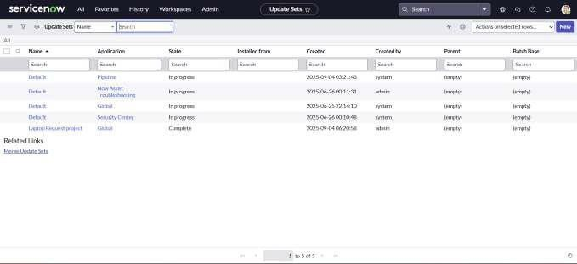

Milestone 2 : Service Catalog Item

Activity 1: Create Service Catalog Item

1. Open service now.
2. Click on All >> service catalog
3. Select maintain items under catalog definitions
4. Click on New.

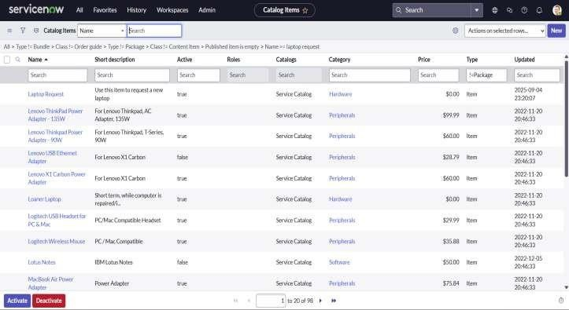

Activity 2: Add variables

Step1:

After saving the catalog item form scroll down and click on variable(related list) Click on new and enter the details as below

* 1. Variable 1:Laptop Model Type: Single line text Name: laptop_model Order:100

Click on submit

Again click on new and add Remaining variables in the above process

* 1. Variable 2:Justification Type: Multi line text Name: justification Order:200
  2. Variable 3:Additional Accessories Type: Checkbox

Name: additional_accessories Order:300

* 1. Variable 4: Accessories Details Type: Multi line text Name:accessories_details Order:400

Step2:

After adding above variable which are added to newly created catalog item Then save the catalog item form

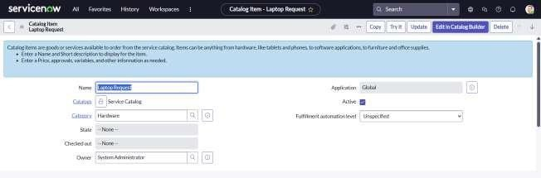

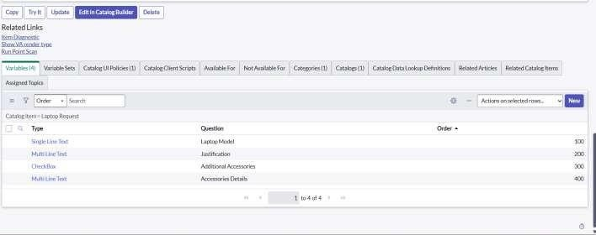

Milestone 3 : UI Policy

Activity 1: Create Catalog Ui policies

1. Click onall>> search forservice catalog
2. Select maintain item under catalog definition
3. Search for ‘laptop request’ which is created before
4. Select ‘laptop request’ and scroll down click on “Catalog Ui policies”
5. In the catalog ui policies related list tab click on new
6. Give short description as: show accessories details
7. Set the Catalog Condition in the related list tab ‘when to apply’ [field: additional_ accessories, operator: is, value: true]

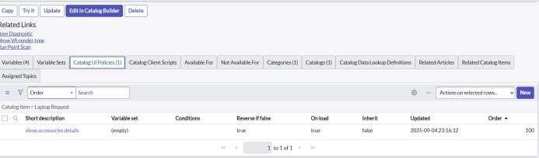

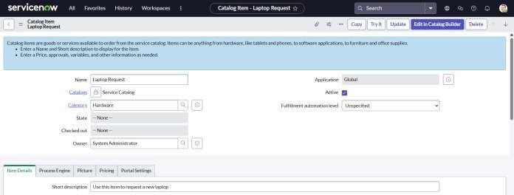

Milestone 4 : UI Action Activity 1: Create ui action

1. Open service now.
2. Click on All >> search for ui action
3. Select ui actions under system definition
4. Click on new
5. Fill the following details to create ui action

Table: shopping cart(sc_cart) Order:100

Action name: Reset form

Client : checked

Code:

Script:

function resetForm() {

g_form.clearForm(); // Clears all fields in the form alert("The form has been reset.");

}

Click on save

Activity 1: Exporting changes to another instances

1. Click on All >> search for update sets
2. Select local update set
3. Select created update set i.e. ‘Laptop Request Project’
4. Set the state to ‘Complete’
5. In the related list Update tab, updates are visible which we perform under this update set.
6. Click on export to XML ,it download one file

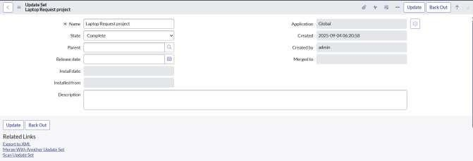

Activity 1:

Testing

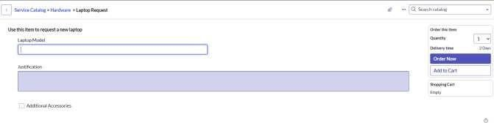

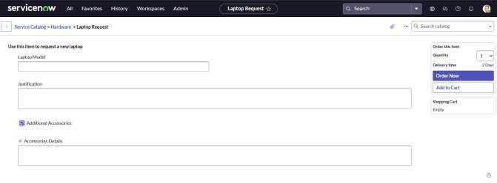

 

Conclusion :

The Laptop Request Catalog Item project successfully streamlines the process of requesting laptops within the organization by leveraging ServiceNow's Service Catalog capabilities. Through the implementation of a dynamic catalog item, the project ensures that users have an intuitive and user-friendly interface, reducing errors and improving efficiency.This project demonstrates how ServiceNow can be used to replace manual, error-prone processes with automated, efficient, and user- centric solutions. It not only improves service delivery but also enhances employee satisfaction by providing a modern and streamlined request experience.